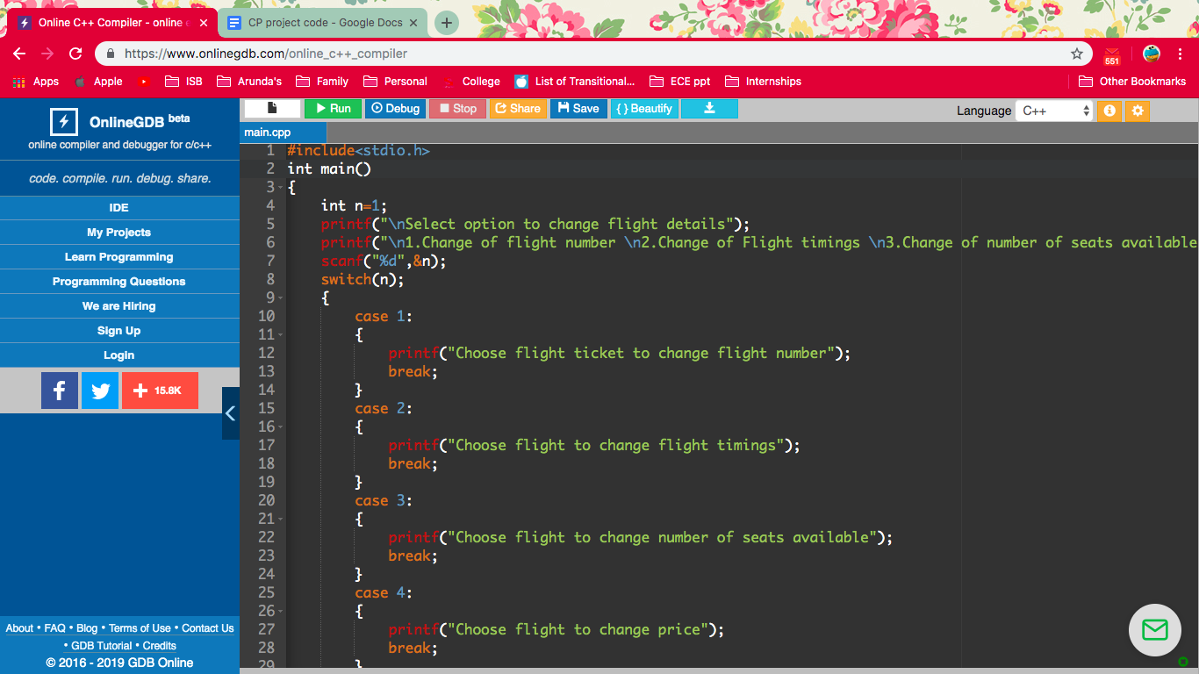

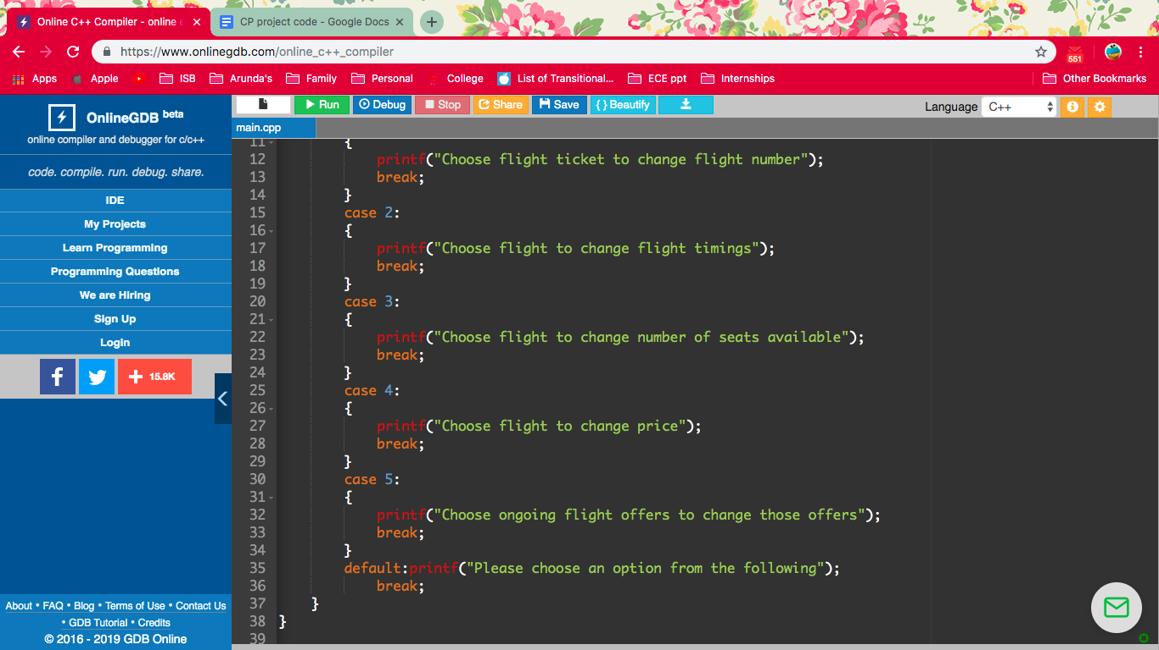

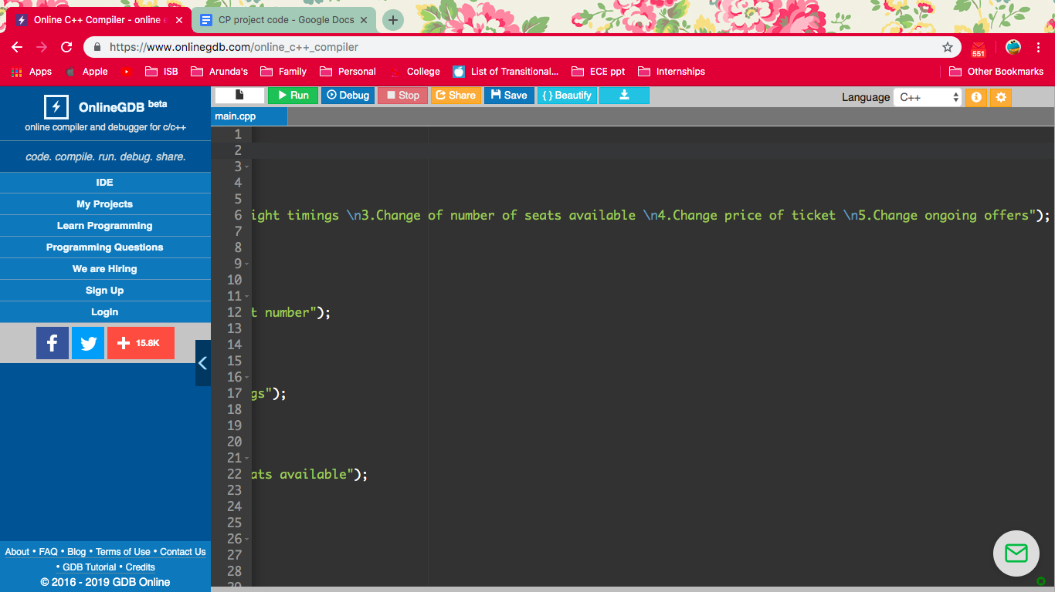

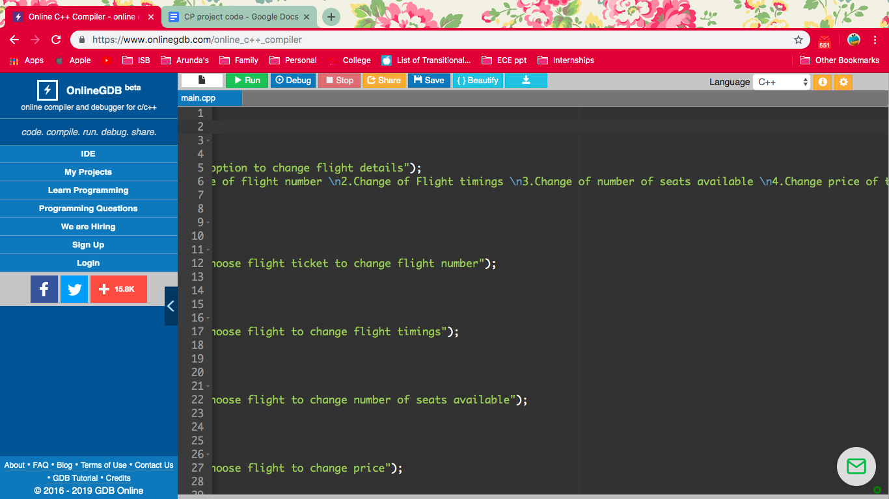

Login system + email address

1. #include <stdio.h>
2. #include <string.h>
3. #include <conio.h>

6. **int** main()
7. {
8. **char** username[15];
9. **char** password[12];

12. printf("Enter your username:\n");
13. scanf("%s",&username);
15. printf("Enter your password:\n");
16. scanf("%s",&password);
18. **if**(strcmp(username,"Tom")==0 && strcmp(password,"123")==0)
19. {
20. printf("\nWelcome.Login Success!");
21. }**else**{
22. printf("\nwrong password");
23. }
24. }**else**{
25. printf("\nUser doesn't exist");
27. printf(“Enter email address:\n”)’;
28. }
29. **return** 0;
31. void main()
32. {

printf(“Enter name:\n”);

printf(“Enter gender:\n”);

printf(“Enter contact number:\n”);

}

2. }

<https://www.daniweb.com/programming/software-development/threads/509427/flight-reservation-in-c-program>